Project Design Phase-II
Technology Stack (Architecture & Stack)

Date | 31 January 3035
Team ID
Project Name
Maximum Marks | 4 Marks

Technical Architecture:

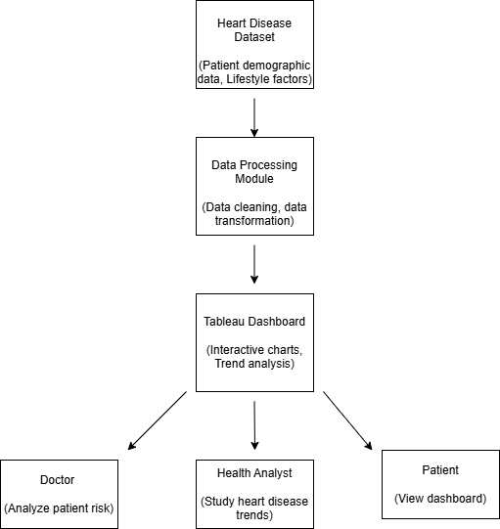

Table 1 – Components & Technologies

S.No | Component | Description | Technology
1. | User Interface | Dashboard for data visualization | Tableau
2. | Data Processing | Data cleaning and preprocessing | Python / Excel
3. | Data Analysis | Statistical analysis of heart disease dataset | Python (Pandas, NumPy)
4. | Visualization Engine | Creation of interactive dashboards | Tableau
5. | Database | Storage of heart disease dataset | MySQL / CSV Dataset
6. | Cloud Database | Cloud data storage (optional) | AWS / Google Cloud
7. | File Storage | Storage of datasets and reports | Local storage / Cloud
8. | External API | Health dataset sources | Kaggle API
9. | Machine Learning Model | Predict heart disease risk (optional) | Scikit-learn
10. | Infrastructure | Deployment of dashboard system | Local system / Cloud

Table 2 – Application Characteristics

S.No | Characteristics | Description | Technology
1. | Open-Source Frameworks | Open-source libraries are used for data preprocessing, cleaning, and analysis of the heart disease dataset before visualization. These frameworks help handle missing values, perform statistical analysis, and prepare structured data for dashboards. | Python, Pandas, NumPy, Matplotlib
2. | Security Implementations | Security measures ensure safe access to the healthcare dataset and dashboards. Access control is applied so only authorized users can view or modify the data. Data transfer is secured to prevent unauthorized access. | HTTPS, User Authentication, Role-Based Access Control (RBAC), Encryption
3. | Scalable Architecture | The system follows a three-tier architecture consisting of data storage, processing, and visualization layers. This architecture allows the system to scale easily when new datasets or dashboards are added. | Tableau, Python, MySQL / Cloud Storage
4. | Availability | Dashboards can be hosted on cloud platforms or Tableau Server so they are accessible anytime for doctors, analysts, and policymakers from different locations. | Tableau Server, Tableau Public, AWS / Cloud Hosting
5. | Performance | Performance is optimized through efficient data processing, filtering, and the use of optimized dashboard queries so that large healthcare datasets can be analyzed quickly. | Tableau Data Extracts, Python Data Processing

